The Power of Images

Introduction
You have the ability to affect people and events in your life.
Power surrounds you: it can consume you: but it can also help you gain control, influence decisions and arouse emotions in people.
People can either bring advantages or disadvantages to people, depending on who is in control.
What is it about the images below that indicates who has the power?
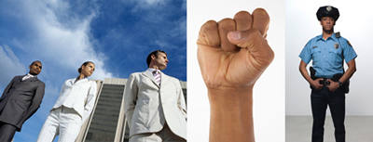
Perhaps you observed that:
- The three people are dressed in business suits and photographed with a skyscraper in the background, suggesting they are successful professionals. A low camera angle has been used to represent them as dominant and powerful.
- The image of the clenched fist has been used to suggest physical strength and power. A close-up shot has been used to emphasise the power represented by the fist.
- The policeman in full uniform has been used as a representation of power in our society. His body language and the stern expression on his face emphasise that this is someone who has power and control over others.
Every day, the images and texts that surround you, from pictures in a magazine to your cereal packet, use symbolic, written, audio and technical codes to influence the way you think and feel about issues.
Visual images are a powerful way to convey ideas and you need to be able to break these codes in order to understand how they can influence you.

Who has the power?
Who has power over you?
Think about two aspects of control – physical and emotional.
Which people and groups in your life seek and gain this control?

The image of the policeman (medium shot) wearing a police vest is used to represent the role of the police in maintaining law and order in our society.
The close-up of the doctor represents health professionals who are responsible for identifying and treating health issues. They have power over us because we rely on them to protect and preserve our health.
The image of a teacher (medium shot) speaking to his class is used to represent the power that teachers have in terms of their ability to provide a sound education for young people.
The image of the larger boy threatening the smaller boy is used to suggest instances of bullying, where one person is disempowered. It represents the power that a physically larger person may have in dominating someone who is smaller and weaker. A long shot has been used to emphasise the differences in size between the two boys.
A low, tilted camera angle has been used to show the young man in a hooded jacket pointing a gun threateningly at the camera. He has the power because he is holding a gun.
We are constantly immersed in images which show representations of both empowered and disempowered groups. Images in magazines, newspapers and books, and images on television, the internet and films all expose us to representations of different power relationships which occur in society.
Before we investigate the influence of visual images, we need to consider who has power in society, how they gain this power and identify who is either disadvantaged or advantaged by this distribution of power.

Brainstorm
Who is in a position of power? Why?
Who is powerless? Why?
In this activity you will:
- Brainstorm which groups have positions of power in society and which ones are powerless.
- Make suggestions about why each group has power or a lack of it.
- List the characteristics that empower and disempower groups in society.

1) Brainstorm

Step 1 Use this template to brainstorm:
- Who is in a position of power?
- Who is powerless?

Some groups have already been provided. Who else can you add?
Use colour, words and images to show whether each group has power or is powerless.
Here are a few suggestions to help you begin:
- elderly
- media magnates
- political leaders

Step 2 Underneath each group suggest why they have this power or the lack of it. Details about the police (authority figures) have been included as an example.

POWER
doctors
Indigenous people
prison guards
Authority figures
police
control through weapons
uniform
legal authority
support
(public/govt)
Minority groups
Step 3
After completing a detailed brainstorm, compile a list of the general characteristics of groups in power and groups that are disempowered in society.

Characteristics of  empowered groups | Characteristics of  disempowered groups
- physical strength  - uniforms | - physically weak  - uneducated

The power of visual language
Have you ever thought about how images make you feel about issues and why?
How does this image make you feel? Why?
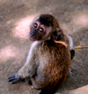
Images can be very powerful in positioning people to respond to issues and they are often used to comment on issues that are of concern in society. Visual language takes many forms such as graffiti, political and social cartoons, posters, advertisements, news images, picture books and graphic novels.

Texts – Visual Images
Use these images for the activities.

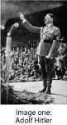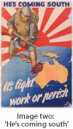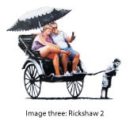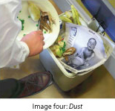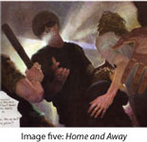
2) Visual images
- Consider each of the following images and answer the questions about power.
Image 1 | Image 2
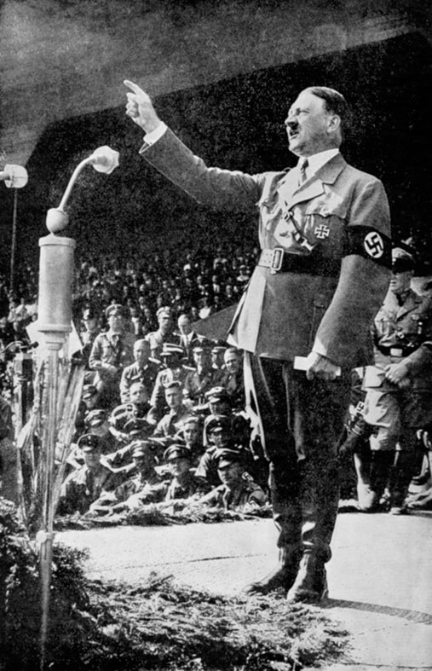 | 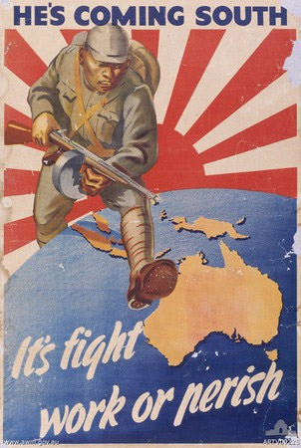  ‘He’s coming south’, 1942, public domain.
What comment is this image making?  _____________________________________  Who appears to be in power?  _____________________________________  How do you know this?  _____________________________________  _____________________________________  _____________________________________  _____________________________________  _____________________________________  _____________________________________  _____________________________________ | What comment is this image making?  _____________________________________  Who appears to be in power?  _____________________________________  How do you know this?  _____________________________________  _____________________________________  _____________________________________  _____________________________________  _____________________________________  _____________________________________  _____________________________________

Image 3 | Image 4
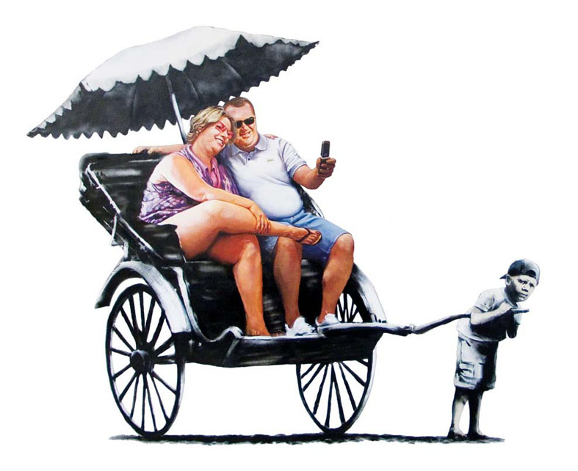  ‘Rickshaw 2’ http://www.banksy.co.uk  Image courtesy of Pest Control Office, reproduced with permission. | 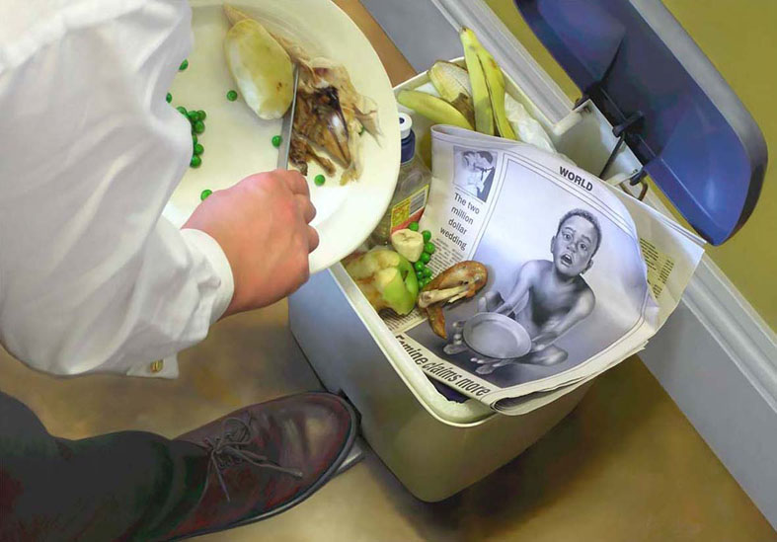  Illustration © David Legge, taken from the book Dust, published by ABC Books, a division of Harper Collins Publishers Australia, to raise money for Save the Children, reproduced with permission.
What comment is this image making?  _____________________________________  Who appears to be in power?  ____________________________________  How do you know this?  _____________________________________  _____________________________________  _____________________________________  _____________________________________  _____________________________________  _____________________________________  _____________________________________ | What comment is this image making?  _____________________________________  Who appears to be in power?  _____________________________________  How do you know this?  _____________________________________  _____________________________________  _____________________________________  _____________________________________  _____________________________________  _____________________________________  _____________________________________

Image 5
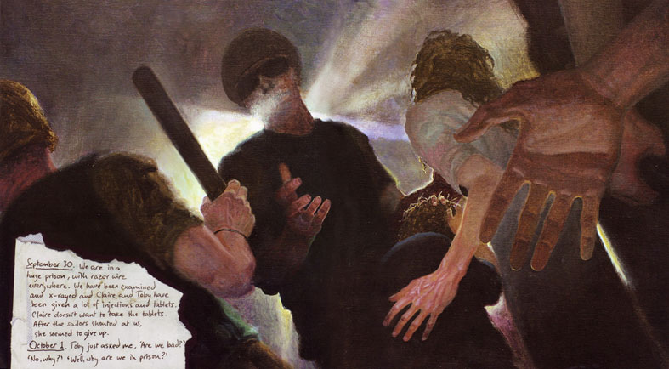
Source taken from book Home and Away, Hachette Australia, reproduced with permission of Matt Ottley, the photographer and John Marsden the author.
What comment is this image making?
_____________________________________________________________________________

Who appears to be in power?
_____________________________________________________________________________
How do you know this?
_____________________________________________________________________________
_____________________________________________________________________________
_____________________________________________________________________________
_____________________________________________________________________________
_____________________________________________________________________________
_____________________________________________________________________________
_____________________________________________________________________________

Context
If you really want to understand how texts can make an impact you need to consider where and when they are created.
The historical and social context of a text is important to consider. When you look at a text, you need to remember that it is not created separately: other factors influence its production. These factors (contexts) affect:
- how a text is created
- how you respond to a text.
The following are the contexts we need to consider:
- social – individuals, groups and how they operate in society
- cultural – way of living, lifestyle, customs and traditions
- historical – events during a particular time period.
These factors can help produce meaning and an awareness of them will influence your interpretation of a text.
The images you have viewed were created in particular historical contexts and it is important to understand the influences of these times in order to understand each image and its purpose. You can explore the historical context of a text's production and the setting of the text to try to interpret what the author may have intended and to develop your response to the text.
Your own context is important too. Your own experiences and background affect your responses to images.
Considering context
How does the context affect different interpretations? Look at each of the images below.
Read the contextual information for each image.

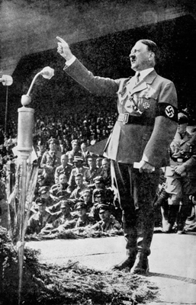
This photograph of Adolf Hitler addressing a Nazi rally was taken in the 1930s. During World War II, Hitler was the chancellor and fuehrer (leader) of the Third Reich in Germany. The Nazi Party, led by Hitler, represented the German national socialists who supported the invasion of neighbouring countries in World War II.

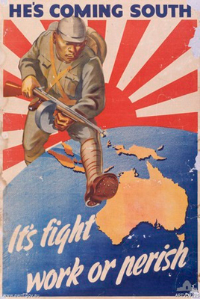
This image is of a World War II propaganda poster. It was produced in Australia in 1942 and portrays the fear of the Japanese invasion at the time. Propaganda posters were common during this period and they were a deliberate attempt to convince the public to support the war and also to recruit men into the armed forces.
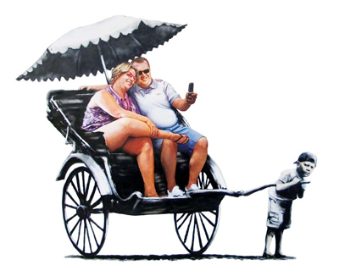
This image was created by graffiti artist Banksy. He is well known for commenting on issues in society, particularly on authoritarian groups and freedom rights. This image was part of an exhibition in 2009 at the Bristol Museum and Art Gallery.
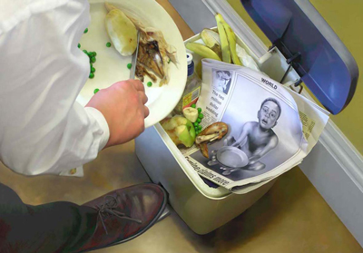
This image was created for the picture book Dust, produced in 2007. The book, inspired by the reported starvation of children in Niger in 2005, was produced to raise money for the children's rights organisation Save the Children. This image occurs near the end of the book and the words 'the world has shut its ears and moved on' accompany the image.

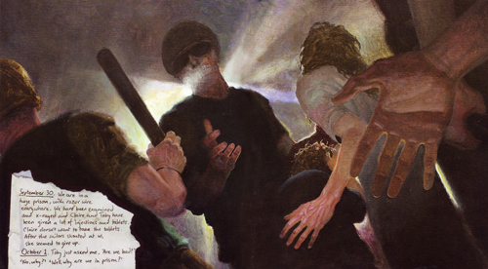
This image was produced in 2008 in the picture book Home and Away. At the time, the refugee population was increasing and Australians were debating solutions to this controversial population growth.

3) Context
- Look back at your responses to the images. Have they changed now that you are fully aware of the historical context?
- Comment on the extent to which your interpretation has changed.
Image | Has your response changed? | Extent to which your response has changed
Hitler
Japanese soldier
Rickshaw
Starving children
Refugees

Representation and visual techniques
Images can influence the way you think and feel about people around you. Consider how you feel about the elderly.
Representation refers to the impression we get of an individual or group due to the language used to construct it. Visual techniques help to convey meaning about an individual, group, subject or issue.
Examine the five images illustrating different representations of the elderly.
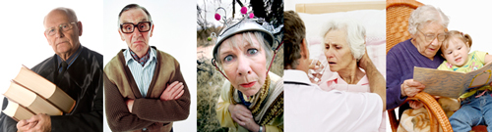
Image one shows an elderly man wearing glasses and an academic gown and holding several large books.
Image two is of a conservatively dressed elderly man standing with his arms crossed and an angry expression on his face.
Image three is a flamboyantly dressed elderly woman who is staring into the camera with a strange, puzzled expression on her face.
Image four shows an elderly woman, thin and dressed in pyjamas, sitting up in a hospital bed and being fed by a nurse.
Image five is of an elderly woman, sitting in a rocking chair, reading to a small child whom she cuddles on her lap.
You can see that they all represent varying views on the same group. Each image offers a representation of the elderly.
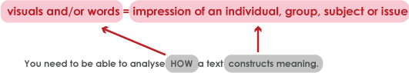
- Choose two images that make you feel strongly about this social group. Describe the representation of two of the images of the elderly provided and explain whether this provides a positive or negative portrayal of this social group.

Codes and Conventions
You need to become a code breaker to understand how visual images construct power.
Examine the images below. How do these images make you feel about the characters portrayed?

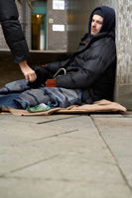
Why do you think they make you feel this way?

When studying images we consider how images are constructed to create meaning. In visuals, we analyse the symbolic, written, audio and technical codes. You may have heard of these already in English: they are often called SWAT codes. For still images, we will focus on how technical and symbolic codes are used to create meaning.
The following table explains the codes you need to recognise when analysing still images and provides questions you can ask to help you respond to the images.

VISUAL TECHNIQUES TABLE
Visual technique | Description | Question
Camera angles | - high camera angle – when the camera is positioned high, looking down on the subject, making the subject appear smaller and weak  - low camera angle – when the camera is positioned low, looking up at the subject, making the subject appear bigger and more powerful  - eye level – when the camera is positioned eye level to the subject | How does the camera angle affect the way you feel towards the subject?
Camera framing | - The way the image is framed determines what information is and what is not available to the viewer. This constructs the meaning we make.  - The main framing lengths are long, medium and close. | How far away or how close is the framing to the subject and how does this make us feel? What can you see more of in the image?
Composition | - position – the location of people or objects in the frame  - place – the setting of the image  - proximity – the placement of people and objects to each other to suggest relationships  - facial expression and gaze – the way the people express emotions and where their eyes are looking in the image  - body language – the gestures and stance of a person. | Who or what holds the attention in the image? How do the background objects add to the meaning?  What is the impact of the setting?  How are people or objects placed in relation to each other? What relationships are suggested?  What are the people looking at and why? What sort of expression is on people’s faces and what feeling does this suggest?  What does the body language suggest?
Colour | Colour can have powerful symbolic meaning as certain colours have connotations to feelings and things. | How does colour or the absence of colour contribute to meaning? Are there connotations of emotions or attitudes?
Clothing | Clothing can be symbolic of a group or a person’s role in society. | What impression do you get of the person’s social class, job, role in society and group they belong to from what they are wearing?

4) Analysing images: Example ‘He’s coming south’
In this activity you will need to read and understand the three different elements of analysing an image, and complete the third, which has been started for you.
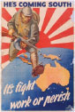
In this example, the image 'He's coming south' is analysed.
- Annotating an image will help you to identify and analyse different elements of the image.
An annotated image identifies and analyses different elements of an image. The comments are usually written beside the image and an arrow will point to an example within the image.
The image 'He's coming south' is a colour poster of a Japanese soldier with gun and bayonet, the Imperial Japanese war flag behind him, the world beneath him and Australia positioned directly under his foot. The annotations for this image would include:

Low camera angle
emphasises power and threat of the soldier
Composition
framing of the Imperial Japanese war flag rising from behind the globe; in the position of the sun
(This comment would be positioned with an arrow pointing at the image of the flag.)
Facial expression
soldier glancing downward, towards Australia; positioned to represent a serious threat
Words
'He's coming south', 'It's fight, work or perish' highlight urgency and indicate danger
(This comment would be positioned with an arrow pointing at the text on the poster.)
Clothing
soldier's uniform: ready for battle
Positioning
positioning of Australia; foreground; suggests immediate need for action
Body language
soldier running; rifle raised as if in battlefield; appears determined and threatening
Colour
red; symbol of danger; also connection to Imperial Japanese war flag

Example of the annotated image

Codes and conventions


Body language
soldier running; rifle raised as if in battlefield; appears determined and threatening
Facial expression
soldier glancing downward, towards Australia; positioned to represent a serious threat
Clothing
soldier’s uniform:
ready for battle
Positioning of Australia; foreground; suggests immediate need for action
Colour
red; symbol of danger; also connection to the Imperial Japanese war flag

Words ‘He’s coming south’, ‘It’s fight, work or perish’ highlight urgency and indicate danger
Composition
framing of the Imperial Japanese war flag rising from behind the globe; in the position of the sun
Low camera angle
emphasises power and threat
of the soldier

‘He’s coming south’, 1942, public domain.
2. You can use the visual techniques table to assist you in identifying the techniques used in an image. It is not necessary to refer to every technique for every image; you need to select the most effective techniques for the image you are analysing.
Example retrieval table
‘He’s coming south’
Technique | Description | Effect on meaning
Camera angle | The soldier is positioned from a low camera angle. | This makes the soldier appear powerful and dominant in the image. It positions the viewer to fear him.
Composition | The man is framed by an Imperial Japanese war flag of World War II and he steps on the globe at Australia. | The flag is rising over the globe as if it is the sun and this suggests the domination of the Japanese over Australia. The man appears to be emerging from within the flag, which promotes the idea that he is an invader and represents all of Japan.
Facial expression and gaze | The man is looking downwards towards Australia on the globe. His expression is serious and focused. | The gaze towards Australia reinforces the threat of the invasion and it builds a sense of fear for Australians. The expression builds tension and suggests that this threat needs to be taken seriously.
Clothing | The man wears military uniform and carries weapons, ready for battle. | The uniform gives the man authority and portrays an imminent threat that is ready for battle. This readiness encourages fear and the need to take action.

3. When constructing a written response to an image, the information you have provided in your retrieval table will help you shape your response.
Read the example paragraphs in the following worksheet, which have been written using the information from the retrieval table. This is an example of how you could shape a written response to an image, addressing the first two techniques, camera angle and composition . Then complete the response, addressing the other two techniques.
A written response to image analysis

Read the example paragraphs below, which have been written using the information from the retrieval table, then complete the response, addressing the other two techniques.
This image is an Australian propaganda poster from World War II. The purpose of the image is to recruit young men for battle. It was used to build public support for the war by portraying the threat to Australia. The creator of this image has used camera angles, composition, facial expression and clothing to represent the Japanese military as a threat and to encourage Australian men to fight for their country.

A low camera angle is used to position the soldier in the poster. This constructs the soldier as powerful and he dominates the frame. The audience is encouraged to fear the soldier and view him as a threat. The low angle makes him appear large and menacing in the image. This builds fear which allows the creator to influence the audience to take action and fight for their country before the enemy overcomes them.

The composition of the setting is important in this image. The soldier is framed by the the Imperial Japanese war flag, which appears as if it is the rising sun. The soldier appears to be emerging from this flag on to the globe and Australia. This suggests that the soldier is Japanese and is on his way to invade Australia. The flag rising above the globe suggests the domination of the Japanese over Australia. This emphasises that invasion is imminent and encourages a sense of urgency to protect the country from this invasion.

The facial expression of the soldier …

The clothing …

5) Conducting a complete image analysis

Now analyse an image yourself.
1. Start by selecting an image which is making a comment on an issue or group in society. Explore its historical, social and cultural context further. Make notes using the following headings as a guide.
- country of origin
- social groups
- traditions and customs of the time
- group represented
- author's background
- issues of the period
- commonly held beliefs.
2. Create an annotated example of the image.
3. Use a retrieval table to assist you in identifying some of the techniques used in the image.
4. Finally, compose a written interpretation, describing the visual techniques used in this image. The information that you recorded in the retrieval table will help you to shape your ideas.
Annotated image

Annotate your choice of image, identifying and analysing different elements of the image.

Paste a print version of the image on he next page

Retrieval table
Complete the retrieval table below for the image you selected.
Technique | Description | Effect on meaning

Written analysis of the image

Compose a written analysis describing the visual techniques used in your chosen image. Use your retrieval table to help shape your ideas.

